
QUALITY ALERT

Customer: Anlin Date: Jan 22, 2021
Die: 15393 Colour: Any
Type of Complaint: Customer REJECTED

Q.A # Q.I.R # CUSTOMER NCR #

Description: Customer REJECTED Weather-strip coming out during processing / saw cut
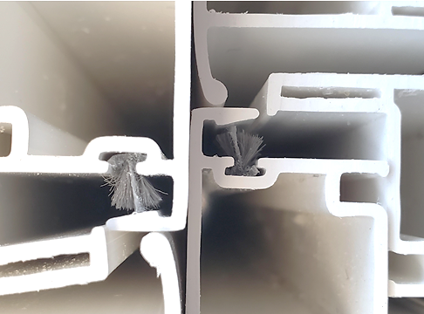

Weather-strip T-slot must be in tolerance so it does not
allow it to come out

Remove weather-strip and make sure it not in and out

BY SIGNING BELOW, YOU ACKNOWLEDGE THE PROBLEM ABOVE AND AGREE TO MONITOR THIS ISSUE IN FUTURE PRODUCTION RUNS.
DAY SHIFT |  | AFTERNOON SHIFT |  | NIGHT SHIFT
NAME | SIGNATURE | NAME | SIGNATURE | NAME | SIGNATURE

